**Seventh Sunday after Pentecost**



**CHRIST LUTHERAN CHURCH** | Lodi, California

*July 27, 2025*

**WELCOME TO WORSHIP**

Welcome to Christ Lutheran Church. We pray that your soul will be strengthened by the good news about God’s grace, love, and forgiveness given to us. If you would like to learn more about our church, please speak with our pastor or one of our members after the service.

* **Bathrooms** are located in the fellowship hall. A changing table is located in the women’s bathroom.

**WORSHIP THEME**

God’s blessings come to us in answer to prayer. Jesus promises that we have a loving Father who wants to give us good gifts. We trust that he will continue to bestow his blessings generation after generation.

From the time of Adam and Eve, God’s people had been waiting for a Savior, a rescuer, someone who would set them free from the curse of sin and death. Throughout the Bible, the promise becomes clearer. He would be born of a woman, a true human. He would be the offspring of Abraham. He would be connected to the royal line of Judah, the greater son of King David. When Jesus was born, he fulfilled all of the prophecies. Our true God came to earth, conceived by the Holy Spirit, born of the Virgin Mary. This series will explore the family tree of our Savior. His lineage is full of unexpected relatives and messy situations. And yet, God used these people to keep his promise to send his Son. Join us as we follow the family tree of the Savior.

***Matins***

*Matins was the service that marked the beginning of a new day for the monastic orders. Morning is a natural and necessary time for prayer, praise, and worship. As we begin not just a new day, but a new week, we glorify God and ask for his blessing.*

**HYMN** *Lord, Teach Us How to Pray***|CW 719**

M: In the name of the Father, and of the Son, and of the Holy Spirit.

**C: Amen.**

M: O Lord, open my lips

**C: And my mouth shall declare your praise.**

M: Hasten to save me, O God.

**C: O Lord, come quickly to help me.**

**CONFESSION**

M: Beloved in the Lord: let us draw near with a true heart and confess our sins to God our Father, asking him in the name of our Lord Jesus Christ to grant us forgiveness.

**C: Holy and merciful Father, I confess that I am by nature sinful, and that I have disobeyed you in my thoughts, words, and actions. I have done what is evil and failed to do what is good. For this I deserve your punishment both now and in eternity. But I am truly sorry for my sins, and trusting in my Savior Jesus Christ, I pray: Lord, have mercy on me, a sinner.**

# absolution

M: God, our heavenly Father, has been merciful to us and has given his only Son to be the atoning sacrifice for our sins. Therefore, as a called servant of Christ and by his authority, I forgive you all your sins in the name of the Father and of the Son ✙ and of the Holy Spirit.

**C**: **Amen**

**PRAYER OF THE DAY**

M: The Lord be with you.

**C: And also with you.**

M: Let us pray.

O Lord, your ears are always open to the prayers of your humble servants who come to you in Jesus’ name. Teach us always to ask according to your will that we may never fail to obtain the blessings you have promised; through your Son, Jesus Christ our Lord, who lives and reigns with you and the Holy Spirit, one God, now and forever.

**C: Amen**

M: The Spirit of the Lord fills the world. Let us worship him.

**O COME LET US SING TO THE LORD**

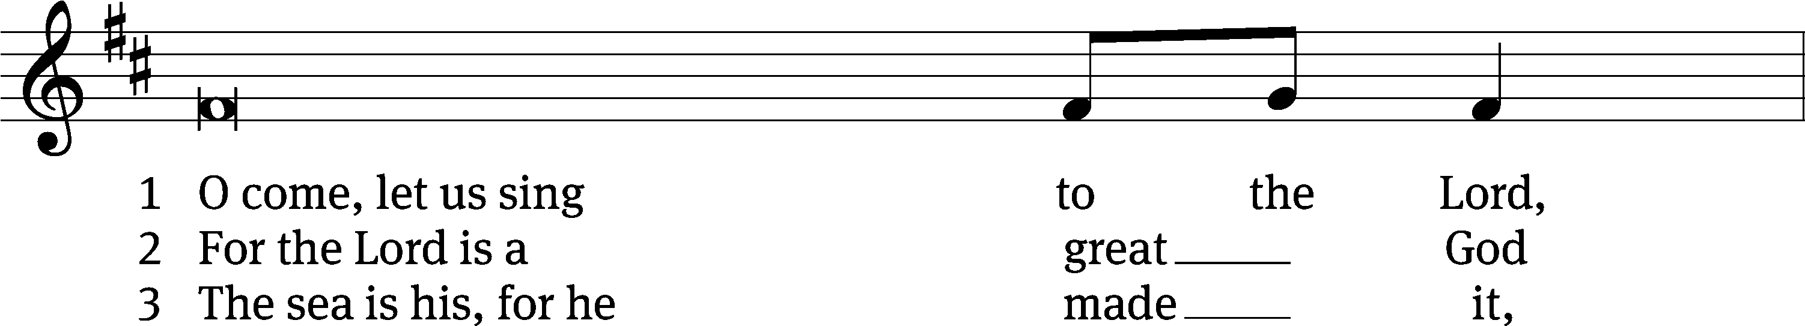

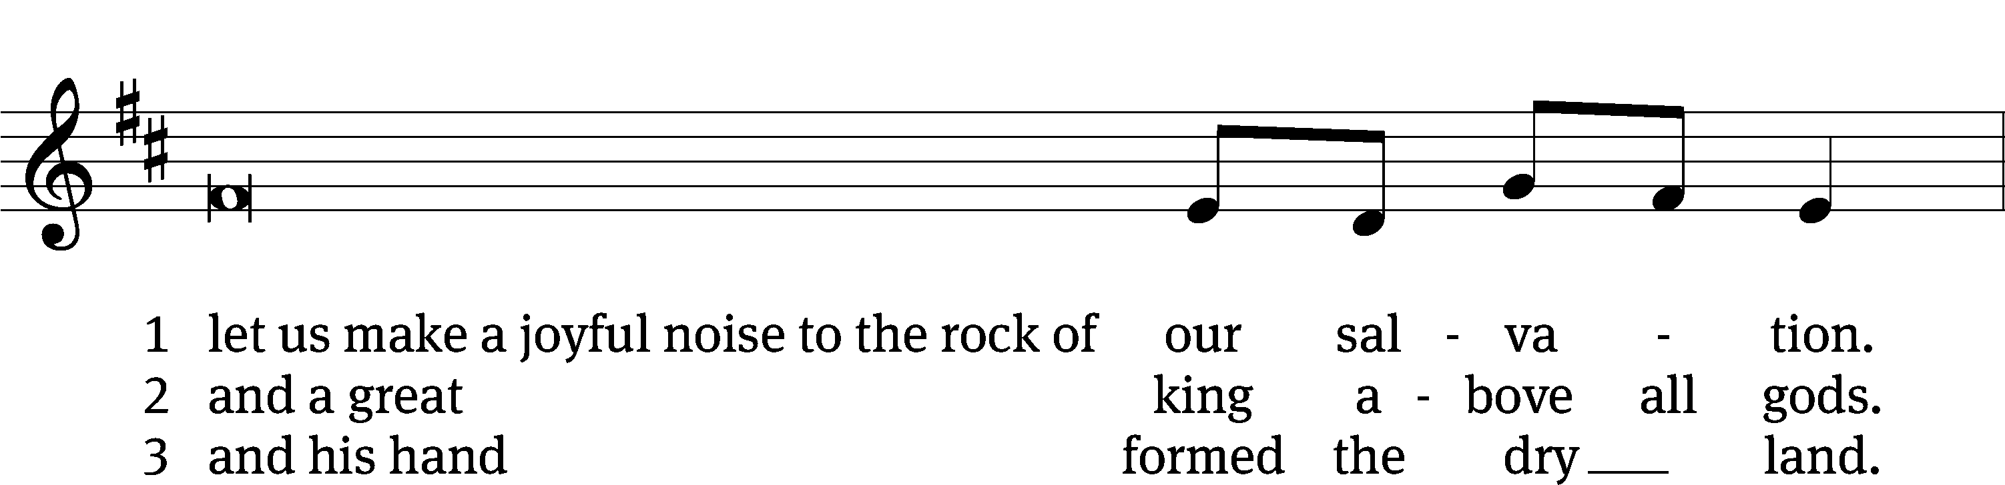

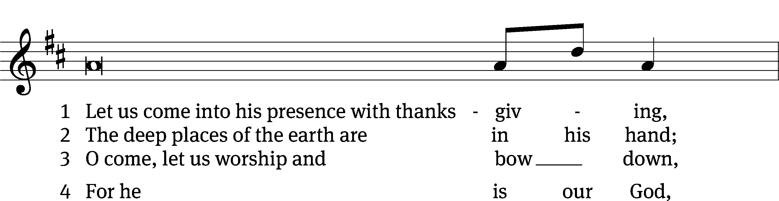

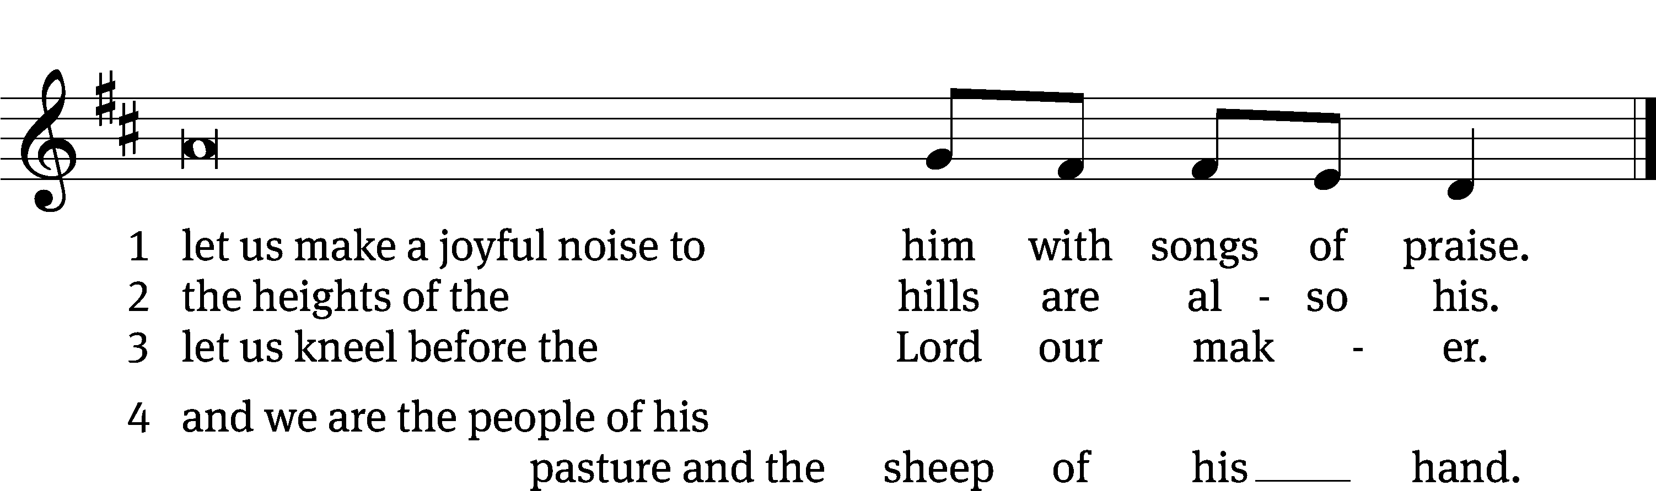

**FIRST LESSON** *Genesis 27:22–41*

*The blessings of Abraham continue to Jacob.*

**22**Jacob went close to his father Isaac, who touched him and said, “The voice is the voice of Jacob, but the hands are the hands of Esau.” **23**He did not recognize him, for his hands were hairy like those of his brother Esau; so he proceeded to bless him. **24**“Are you really my son Esau?” he asked.

“I am,” he replied.

**25**Then he said, “My son, bring me some of your game to eat, so that I may give you my blessing.” Jacob brought it to him and he ate; and he brought some wine and he drank. **26**Then his father Isaac said to him, “Come here, my son, and kiss me.”

**27**So he went to him and kissed him. When Isaac caught the smell of his clothes, he blessed him and said,

“Ah, the smell of my son  
    is like the smell of a field  
    that the Lord has blessed.  
**28**May God give you heaven’s dew  
    and earth’s richness—  
    an abundance of grain and new wine.  
**29**May nations serve you  
    and peoples bow down to you.  
Be lord over your brothers,  
    and may the sons of your mother bow down to you.  
May those who curse you be cursed  
    and those who bless you be blessed.”

**30**After Isaac finished blessing him, and Jacob had scarcely left his father’s presence, his brother Esau came in from hunting. **31**He too prepared some tasty food and brought it to his father. Then he said to him, “My father, please sit up and eat some of my game, so that you may give me your blessing.”

**32**His father Isaac asked him, “Who are you?”

“I am your son,” he answered, “your firstborn, Esau.”

**33**Isaac trembled violently and said, “Who was it, then, that hunted game and brought it to me? I ate it just before you came and I blessed him—and indeed he will be blessed!”

**34**When Esau heard his father’s words, he burst out with a loud and bitter cry and said to his father, “Bless me—me too, my father!”

**35**But he said, “Your brother came deceitfully and took your blessing.”

**36**Esau said, “Isn’t he rightly named Jacob[[a](https://www.biblegateway.com/passage/?search=genesis%2027%3A22-41&version=NIV#fen-NIV-764a)]? This is the second time he has taken advantage of me: He took my birthright, and now he’s taken my blessing!” Then he asked, “Haven’t you reserved any blessing for me?”

**37**Isaac answered Esau, “I have made him lord over you and have made all his relatives his servants, and I have sustained him with grain and new wine. So what can I possibly do for you, my son?”

**38**Esau said to his father, “Do you have only one blessing, my father? Bless me too, my father!” Then Esau wept aloud.

**39**His father Isaac answered him,

“Your dwelling will be  
    away from the earth’s richness,  
    away from the dew of heaven above.  
**40**You will live by the sword  
    and you will serve your brother.  
But when you grow restless,  
    you will throw his yoke  
    from off your neck.”

**41**Esau held a grudge against Jacob because of the blessing his father had given him. He said to himself, “The days of mourning for my father are near; then I will kill my brother Jacob.”

**PSALM**  *Psalm 138*

**SECOND LESSON** *1 Timothy 2:1–7*

*Christians are to pray regularly for people in every station.*

**2**I urge, then, first of all, that petitions, prayers, intercession and thanksgiving be made for all people— **2**for kings and all those in authority, that we may live peaceful and quiet lives in all godliness and holiness. **3**This is good, and pleases God our Savior, **4**who wants all people to be saved and to come to a knowledge of the truth. **5**For there is one God and one mediator between God and mankind, the man Christ Jesus, **6**who gave himself as a ransom for all people. This has now been witnessed to at the proper time. **7**And for this purpose I was appointed a herald and an apostle—I am telling the truth, I am not lying—and a true and faithful teacher of the Gentiles.

**VERSE OF THE DAY** *Luke 11:9*

**Alleluia. Ask and it will be given to you; seek and you will find; knock and the door will be opened to you. Alleluia.**

**THE GOSPEL** *Luke 11:1–13*

*Jesus teaches his disciples to pray—and why to pray.*

**11**One day Jesus was praying in a certain place. When he finished, one of his disciples said to him, “Lord, teach us to pray, just as John taught his disciples.”

**2**He said to them, “When you pray, say:

“‘Father,   
hallowed be your name,  
your kingdom come.   
**3**Give us each day our daily bread.  
**4**Forgive us our sins,  
    for we also forgive everyone who sins against us.   
And lead us not into temptation.’”

**5**Then Jesus said to them, “Suppose you have a friend, and you go to him at midnight and say, ‘Friend, lend me three loaves of bread; **6**a friend of mine on a journey has come to me, and I have no food to offer him.’ **7**And suppose the one inside answers, ‘Don’t bother me. The door is already locked, and my children and I are in bed. I can’t get up and give you anything.’ **8**I tell you, even though he will not get up and give you the bread because of friendship, yet because of your shameless audacity[[e](https://www.biblegateway.com/passage/?search=luke%2011%3A1-13&version=NIV#fen-NIV-25414e)] he will surely get up and give you as much as you need.

**9**“So I say to you: Ask and it will be given to you; seek and you will find; knock and the door will be opened to you. **10**For everyone who asks receives; the one who seeks finds; and to the one who knocks, the door will be opened.

**11**“Which of you fathers, if your son asks for[[f](https://www.biblegateway.com/passage/?search=luke%2011%3A1-13&version=NIV#fen-NIV-25417f)] a fish, will give him a snake instead? **12**Or if he asks for an egg, will give him a scorpion? **13**If you then, though you are evil, know how to give good gifts to your children, how much more will your Father in heaven give the Holy Spirit to those who ask him!”

M The Gospel of the Lord.

**C: Praise be to you, O Christ!**

**HYMN OF THE DAY** *What a Friend We Have in Jesus***| CW 721**

**SERMON** *Luke 11*

**WE PRAISE YOU, O GOD**

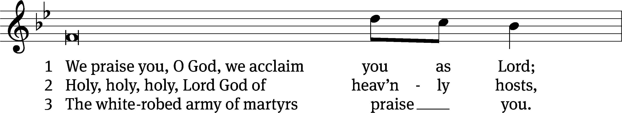

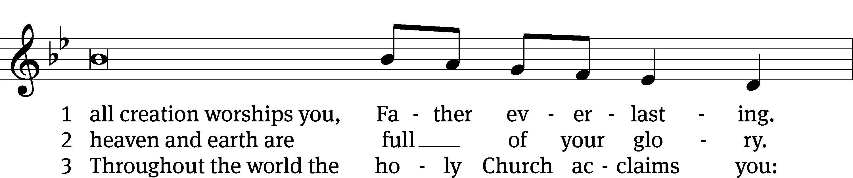

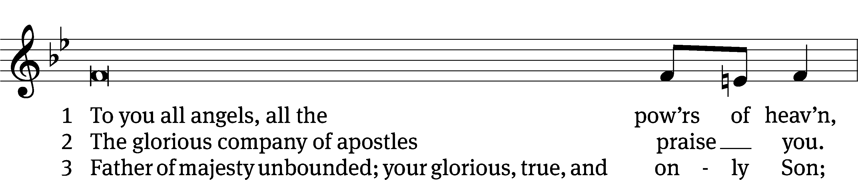

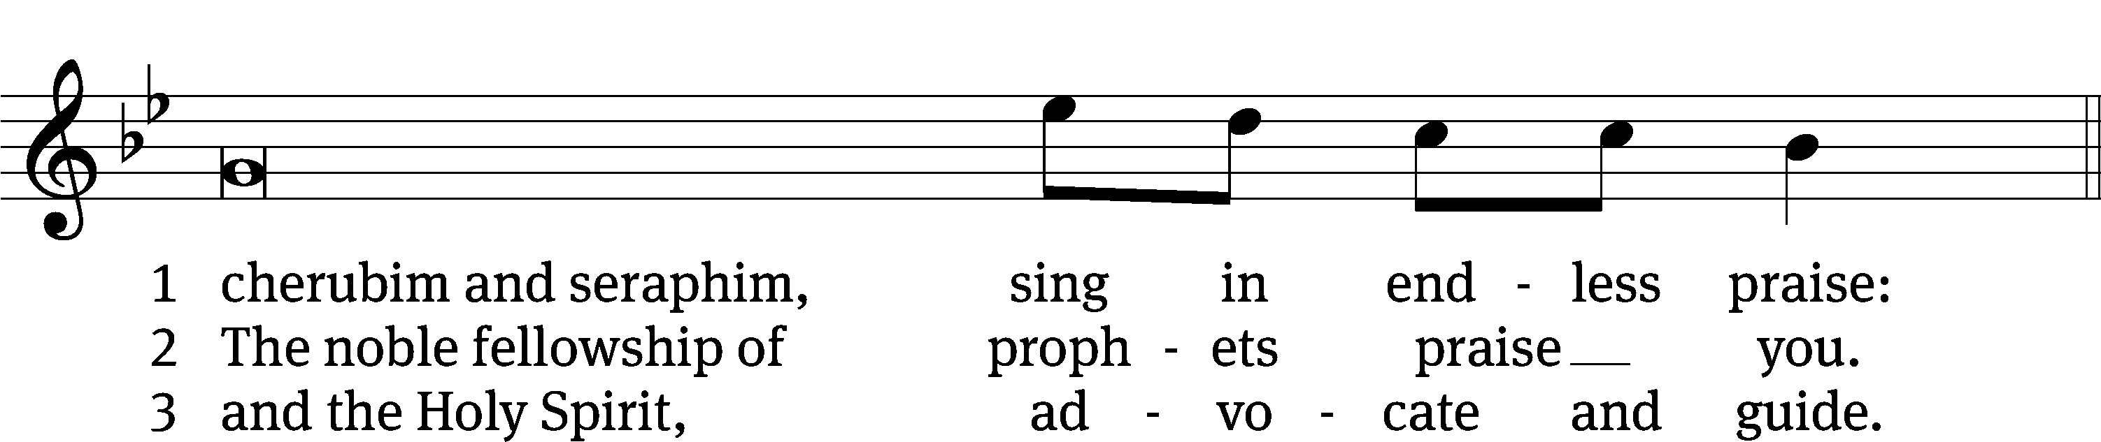

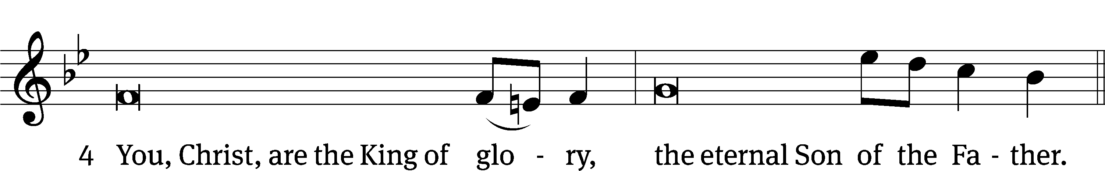

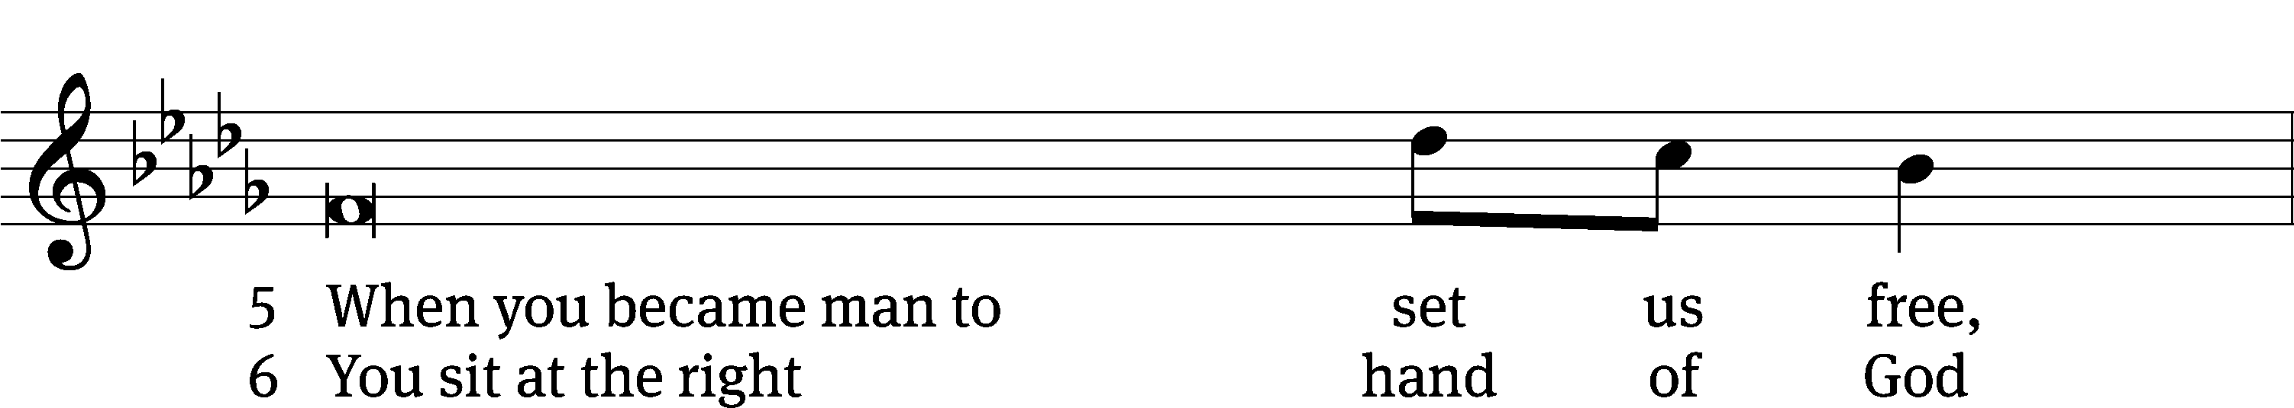

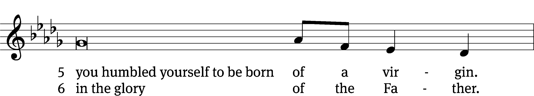

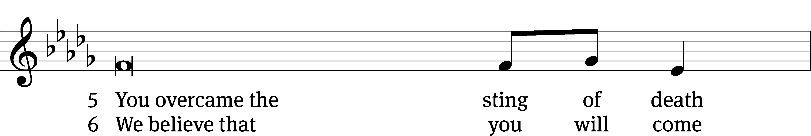

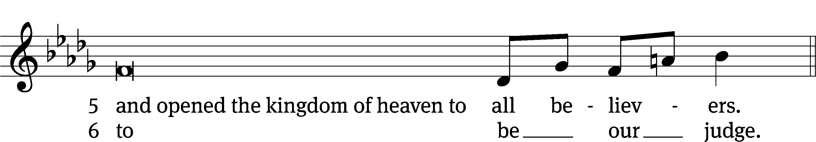

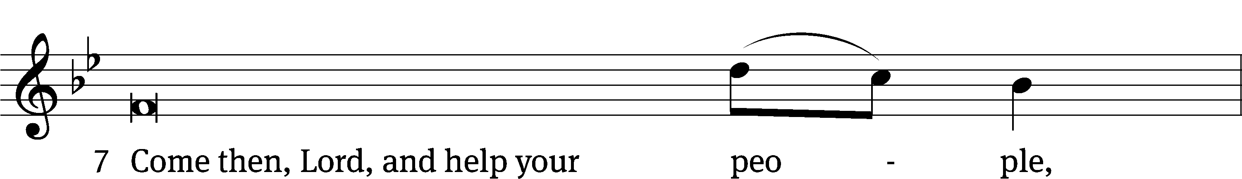

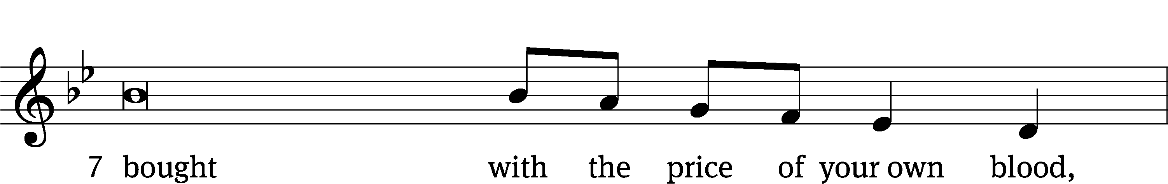

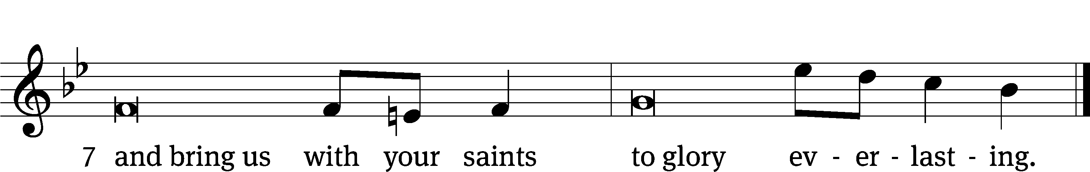

**OFFERING**

*In response to God’s love and forgiveness, we give back a portion of what he has given us. The members of Christ Lutheran Church have joined to proclaim the gospel to this community. These offerings support that work. While our guests are welcome to participate, they should not feel obligated to do so.*

**PRAYER OF THE CHURCH**

M: Heavenly Father, You hear the prayers of Your dear children and care for all their needs of body and soul. As we come before You with our petitions, unburden our hearts from the weight of our sins and troubles, and give us faith to live in light of Your promises. Lord, in Your mercy,

**C: Hear our prayer.**

M: O Lord, You have bestowed a high honor and duty upon Your Church by teaching her to pray and promising to hear her. Bless our pastors in their prayers for Your people, and hear us all as we offer our petitions in the name of Jesus. Lord, in Your mercy

**C: Hear our prayer.**

M: Everlasting God, You have called the hearts of fathers to their children by bringing Your Son into our world. Nurture the life of prayer in the homes of Your people, that we all would know the full blessing of Your fatherly care. May parents not show favoritism, and may children heed the discipline of their parents. Lord, in Your mercy,

**C: Hear our prayer.**

M: Lord God, You have ordered the nations that men would seek after You. Curb the wickedness of this world, embolden the witness of the righteous, and make our nation a repentant and faithful place where Your gracious presence is welcomed with thanksgiving. Lord, in Your mercy,

**C: Hear our prayer.**

M: Righteous Lord, You do not wink at wickedness, and You promise that Your patience with evil will not last forever. As You punished Sodom and rescued Lot in days of old, save Your people today and vanquish our enemies. Give us prayerful hearts to leave all vengeance in Your hands. Lord, in Your mercy,

**C: Hear our prayer.**

M: Almighty God, You promise to hear our prayers and, through them, to involve us in Your divine plan. As You heard and considered the prayers of faithful Abraham, hear our prayers on behalf of [_____________ and] all who suffer. Spare their lives, and through all things draw them ever closer to You. Lord, in Your mercy,

**C: Hear our prayer.**

*Silent prayer*

M: Heavenly Father, we ask Your blessing and look to You as the Giver of all good gifts. Make us ever eager to come to You in prayer and thanksgiving, as Your Son has taught us. By Your Holy Spirit, bring us to behold in Christ the fulfillment of those things for which we pray — Your holy name, Your coming kingdom, daily bread, forgiveness, shelter in temptation and deliverance from every evil; through the same Jesus Christ, Your Son, our Lord, who lives and reigns with You and the Holy Spirit, one God, now and forever.

**C: Amen.**

**LORD’S PRAYER** *Matthew 6:9-13; Luke 11:2-4*

**C: Our Father in heaven, hallowed be your name,**

**your kingdom come, your will be done on earth as in heaven.**

**Give us today our daily bread; and forgive us our sins,**

**as we forgive those who sin against us;**

**and lead us not into temptation, but deliver us from evil.**

**For the kingdom, the power, and the glory are yours**

**now and forever. Amen.**

**THE BLESSING**

M**:** The Lord bless you and keep you.

The Lord make his face shine on you and be gracious to you.

The Lord look on you with favor and ✙ give you peace.

**C: Amen.**

**CLOSING HYMN** *May the Peace of God***| CW 929**

**COPYRIGHT INFORMATION**

*Content requiring a copyright license is reproduced under OneLicense.net #A-718312. All rights reserved. The Common Service: Texts revised from The Lutheran Hymnal, 1941. Music revised by James Engel. Scripture Quotations: From the Holy Bible, New International Version (NIV 1984), © 1973, 1978, 1984 by Biblica, Inc.*



**13009 N. Elderberry Ct.**

**Lodi, CA 95242**

[www.christlodi.org](http://www.christlodi.org)

209-368-6250

Pastor Timothy Leistekow

**WELCOME TO CHRIST EV. LUTHERAN CHURCH!**

We preach a message of forgiveness, hope and peace

through the death and resurrection of Jesus Christ.

Families and individuals of all ages will find opportunities

both to grow and to serve.

Our mission statement:

**Look what Christ is doing!**

He binds us together in fellowship

He gathers us in for worship

He builds us up for service

He sends us out with the gospel

*“Now you are the body of Christ,*

*and each one of you is a part of it.”*

*(1 Corinthians 12:27)*